|  |
| --- |
|  |

|  |  |
| --- | --- |
| **Document Information** | |
| **Attribute** | **Information** |
| **File name** | **SWG70-EIP-Test Plan_JC-20191008 .docx** |
| **Department** | **Products & Solutions - TQP** |

|  |  |  |  |
| --- | --- | --- | --- |
| **Created by** | | | |
| Name (forename surname) | Role (Management System) | Date (YYYY-MM-DD) | Signature |
| Jean Coudert | Team Leader (TQP) | 2019-10-08 |  |

|  |  |  |  |
| --- | --- | --- | --- |
| **Reviewed by** | | | |
| Name (forename surname) | Role (Management System) | Date (YYYY-MM-DD) | Signature |
| OliverKuttruff | Test Expert (TQP) |  |  |

|  |  |  |  |
| --- | --- | --- | --- |
| **Approved by** | | | |
| Name (forename surname) | Role (Management System) | Date (YYYY-MM-DD) | Signature |
| Frédéric Willauer | Product owner |  |  |

**The approval signatures in this document signify that the entire content of this document, especially in terms of its completeness and accuracy are sufficient and satisfactory to provide the solid basis for a successful project execution.**

Table of Contents

1. Introduction 3

1.1 Purpose 3

1.2 Objectives 3

1.3 Scope 4

2. Requirements 5

2.1 Test execution in general 5

2.2 Defects 6

2.3 Test automation 6

3. Test Risks 6

4. Test Strategy 6

4.1 Test Process and Phases 6

4.2 Installation tests 6

4.2.1 Tested operating systems: 6

4.2.2 Tested languages 6

4.2.3 Tested processor architecture 6

4.3 Basic features 6

4.4 SMT70 tablet and CommDTM for remote access with HART field device 6

4.5 Reliability tests 7

4.6 Long term tests stability 7

4.7 Performance tests 7

5. Test Iteration 8

6. Measuring and test equipment 8

7. References 8

8. Revision History 8

9. Glossary 9

# Introduction

## Purpose

This document describes the testing rules for the project referred in the document header. This document is used by the test expert as a guidance for all testing activities and by the product owner to follow and supervise planned deliveries.

## Objectives

1. The main target of the following tests is a **validation** of the SWG70 Firmware delivery of "PEPPERL+FUCHS” and his related Communication DTM of “CodeWrights”. This validation will be focused on Internal DS engineering projects (FieldCare PAM Gateway functionality + Condition Monitoring). It is assumed that both deliveries have a decent quality level and that each of them has been previously **verified** at least with 2 HART devices (Test reports/notes with list of known issues) [Ref1] [Ref2]  
     
   The CommDTM module: Wireless HART DTM Library Update - Version 1.03.02  
     
   The Firmware: WHA-GW WirelessHART Gateway device 2.0
2. In the other hand, it will be verified that:
   1. Bugs found in the previous delivery have been fixed in this delivered version.
   2. New implemented features work properly
   3. Improvements works properly
   4. A regression test will be executed to verify that all previous working features still working with the new delivered FW and CommDTM.

## Scope

The document is applicable in the project ‘SWG70-EIP’ and executed within within ‘M’ and supported by ‘T’  
  
All already existing Test Suites are located in RQM in "Wireless Sensor Network" project under the following Link: < [SWG70 EtherNet/IP FW 02.00.01](https://pcps-qm.emea.endress.com:9443/qm/web/console/Wireless%20Sensor%20Network%20(Quality%20Management)#action=com.ibm.rqm.planning.home.actionDispatcher&subAction=viewTestPlan&id=539)>

Those Test Suites are divided into many topics, but not all are up-to-date with the new delivered FW and CommDTM version. The status of the TCs and the TSs are related to the last EIP released FW V 1.00.00 delivery.

This means that all TC and TS must be checked to verify that they still valid and adapt them if needed. However, new implemented features or fixed bugs are currently not covered by these TC or TS and new ones shall be created to cover efficiently this new delivered version.

New features, Improvments, fixed Bugs will be listed in the following paragraph [Ref.1].

**Feature scope**

1. SUMMARY OF CHANGES
   1. Whitelisted Security Mode
   2. Wireless-level Join Key Change
   3. Advanced Cache Management
   4. Special Operating Modes
   5. Performance Improvements
   6. Protocol Improvements
   7. Stale Data Detection
   8. Security Update
2. NEW FEATURES
   1. Stale Data detection
   2. Network Security support
   3. Substitution Values management
   4. Burst Configuration Caching
   5. Additional Cached Commands
   6. Special Operating Modes management
   7. Improved Identification procedure
   8. Performance-related improvements
   9. Pass-Through Mode

1. ADDITIONAL IMPROVEMENTS
   1. Web IF User Levels
   2. Software Upgrade Procedure
   3. HART-IP protocol
   4. Command 75 & 77
   5. Identification procedure improved
   6. Usage of cache for aggregated wireless requests
   7. Other improvements

1. BUG FIXES
   1. Firmware upgrade
   2. Web Interface
   3. EtherNET-IP Process
   4. Other bugs

**Test scope** **environment**

* Condition Monitoring Functional and long-term tests
* Remote connection 1 With SMT70 tablet and CommDTM
* Remote connection 2 With FiledCare and CommDTM
* Data transfer Test device data transfer to Netilion
* Reliability Stable communication
* Performance Memory consumption, CPU usage, etc
* Operating systems Windows 10 / English / 64 bits
* Previous fearures work Manual Regression tests

# Requirements

* + Verification of key features (Incoming goods): Done by CodeWrights and P+F
  + Validation of product (outgoing goods): At the end of the previous test phase, SAS will produce a small confirmation that the intended use of the SWG70 FW version 2.0 and the CommDTM Version 1.03.02 have been fulfilled according to customer procedure.

## Test execution in general

Test cases are managed and Executed in the Jazz platform (QM) and may be executed as Regression Test.

In all other cases a session-based tests or Exploratory tested will be executed and documented by an experienced tester which knows the environment.

## Defects

Change requests are managed in the Jazz platform (CM).

Defects found during this project are reported in Word documents which will be communicated to P+F or CW.

## Test automation

No Test automation required in this project.

# Test Risks

The main risk is to get a none or not full tested/verified deliveries which certifies that several tests have already been performed at CW and by P+F.

# Test Strategy

## Test Process and Phases

The test process is based on Kanban process at DCMS Squad.

## Installation tests

### Tested operating systems:

* Windows 10

### Tested languages

* EN

### Tested processor architecture

* 64-bit

## Basic features

Basic features are tested according to priorization.

## SMT70 tablet and CommDTM for remote access with HART field device

Mobile device access is a must E+H for this release. Session based tests will cover the following:

* The scenario under test is in principle working
* Stability

The picture below shows roughly how the different components interact. This test environment is based on a Rockwell infrastructure as close as possible to a client configuration. The goal is to verify that Device values are correctly transported to the Cloud (Netilion) via SWG70.

**PS**: If this is possible some HART devices should be connected to SWA50 FieldPort to combine both projects

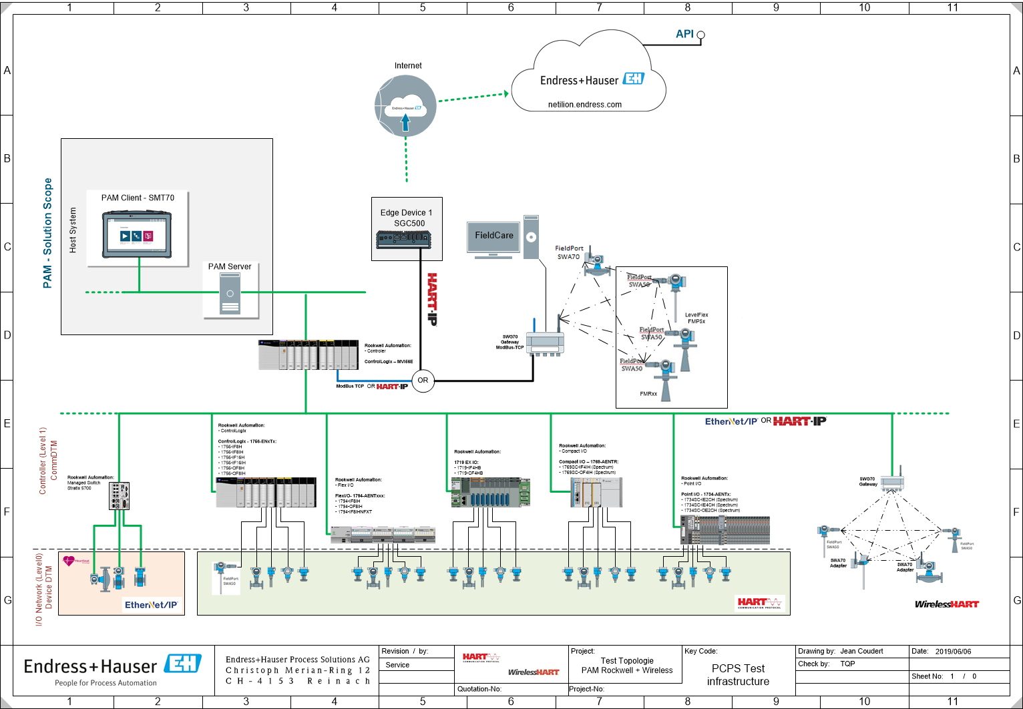

## Reliability tests

Remove network cables, turn off/on the power of the Gatewat SWG70 or Adaptor SWA70 and disconnect/connect HART Devices. Check that information is correctly displayed and that system still working properly.

## Long term tests stability

Long term stability is a must for E+H for this release. Session based tests will cover the following:

* Condition monitoring using various IO modules
* Stability of condition monitoring
* Memory consumption during condition monitoring
* Remote access with SMT70/FieldCare client

Condition Monitoring test should work properly without any break during at least 14 days.

## Performance tests

Memory consumption/leak, CPU usage, etc.

# Test Iteration

Only one test iteration is planed for thios project.

* Test Design phase which should be used to Update already existing Tests cases/Suites and create new ones
* Test Execution phase which contains execution of Test Cases, Exploratory tests and non functional tests (Reliability tests, Long term tests, Performance tests)

This Test iteration phase has been planned to 4 working weeks and will be carried out by the following persons:

* Oliver Kuttruff (Test Expert by TQP) for Support, design, coordination and execution of all related test activities
* Corinna Fräulin (MP) for Test design and Test execution.

Project number:

* 12110006 SCS-WH Maintenance and Support WSN (New Firmware for SWG70)

# Measuring and test equipment

A dedicated Rockwell test environment is in place.

# References

This chapter lists any type of reference like text, documents, organizations, etc. The references shall support the reader in identifying referenced items and accessing the appropriate artifact.

|  |  |  |
| --- | --- | --- |
| **Reference ID [Refx]** | **Short Term** | **Title / Path & file name / Version & Date** |
| [Ref1] | N.A. | Name: Endress+Hauser Process Solutions - Wireless HART DTM Library Update  Reference: AcceptanceRecord - Endress+Hauser Wireless HART DTM Library 1.03.02.docx |
| [Ref2] | N.A. | Name: Software 2.0 Release Notes – Namur version 02.00.01  Reference: WHA-GW WIRELESS HART GATEWAY.pdf |
| [Ref3] | N.A. | Name:  Reference: |
| [Ref4] | N.A. | Name:  Reference: |

All documents stored in SharePoint.

# Revision History

|  |  |  |  |  |
| --- | --- | --- | --- | --- |
| **Revision History** | | | | |
| **Rev.** | **State** | **Date (YYYY-MM-DD)** | **Author** | **Comment** |
| 0.1 | Draft | 2018-10-08 | Jean Coudert | Initial draft |
| 0.2 |  |  |  |  |
| 0.3 |  |  |  |  |
| 0.4 |  |  |  |  |

# Glossary

|  |  |  |
| --- | --- | --- |
| **Short term** | **Term** | **Explanation** |
| CW | CodeWrights | CommDTM supplier |
| P+F | PEPPERL+FUCHS | SWG70 – FW supplier |
| DCM | Device Configuration Management | N.A. |
| FNE | Field Network Engineering | N.A. |
| TQP | Technology Product & Sysytem Test | N.A. |
| TQO | Technology Operational Resources | N.A. |
| MP | Marketing Product | N.A. |
| RA | Rockwell Automation | N.A. |